1. Introduction
2. Project Overview
3. Requirements
4. Methodology
5. System Design
5.1 Architecture
The SmartBistro system is designed using a three-tier architecture to ensure scalability, maintainability, and clear separation of concerns. The system is divided into three main layers: the presentation layer, the application layer, and the data layer.
The presentation layer represents the user interface, which is accessed by customers and staff through mobile devices or tablets. It includes features such as QR-based menu access, ordering interface, and dashboard displays.
The application layer handles the core business logic of the system. This includes processing orders, managing payments, updating inventory, and handling communication between different modules such as the Kitchen Display System and notification services.
The data layer is responsible for storing and managing all system data using a relational database (PostgreSQL). It ensures data integrity and supports concurrent transactions, which is essential for handling multiple orders simultaneously.
This layered architecture allows the system to operate efficiently while maintaining flexibility for future enhancements.
5.2 Use case diagram
The use case diagram illustrates the interactions between different actors and the SmartBistro system. The primary actors include customers, staff, and kitchen personnel. Customers interact with the system to browse menus, place orders, and complete payments, while staff manage tables and assist operations. The kitchen staff receives and processes orders in real time. The system also handles background processes such as payment processing, inventory updates, and email notifications.
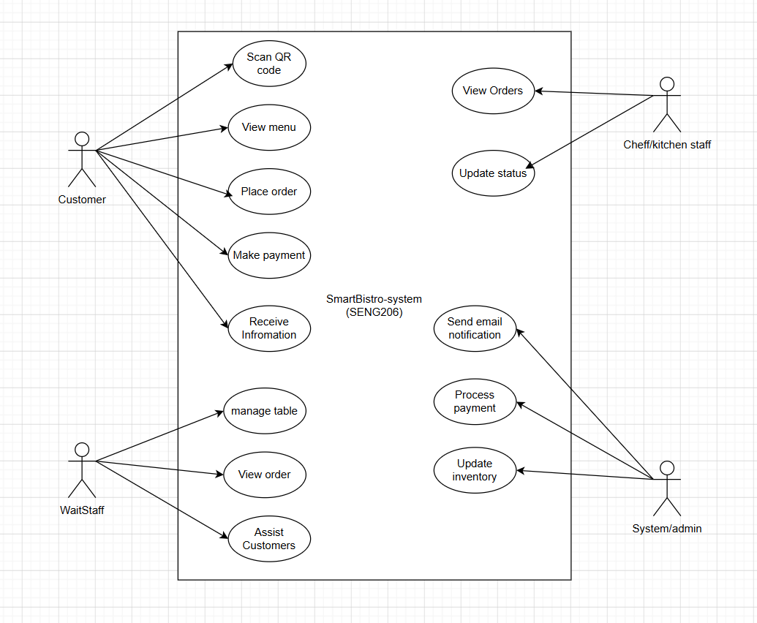
5.3 - Sequence diagram:
The sequence diagram demonstrates the step-by-step interaction between system components during order processing.
Sequence Diagram: Customer Order & Email Confirmation
Actors / Objects included:
- Customer
- Mobile Web Interface / QR Menu
- Order System
- Payment Gateway
- Database
- Email Service
- Kitchen Display System (KDS)

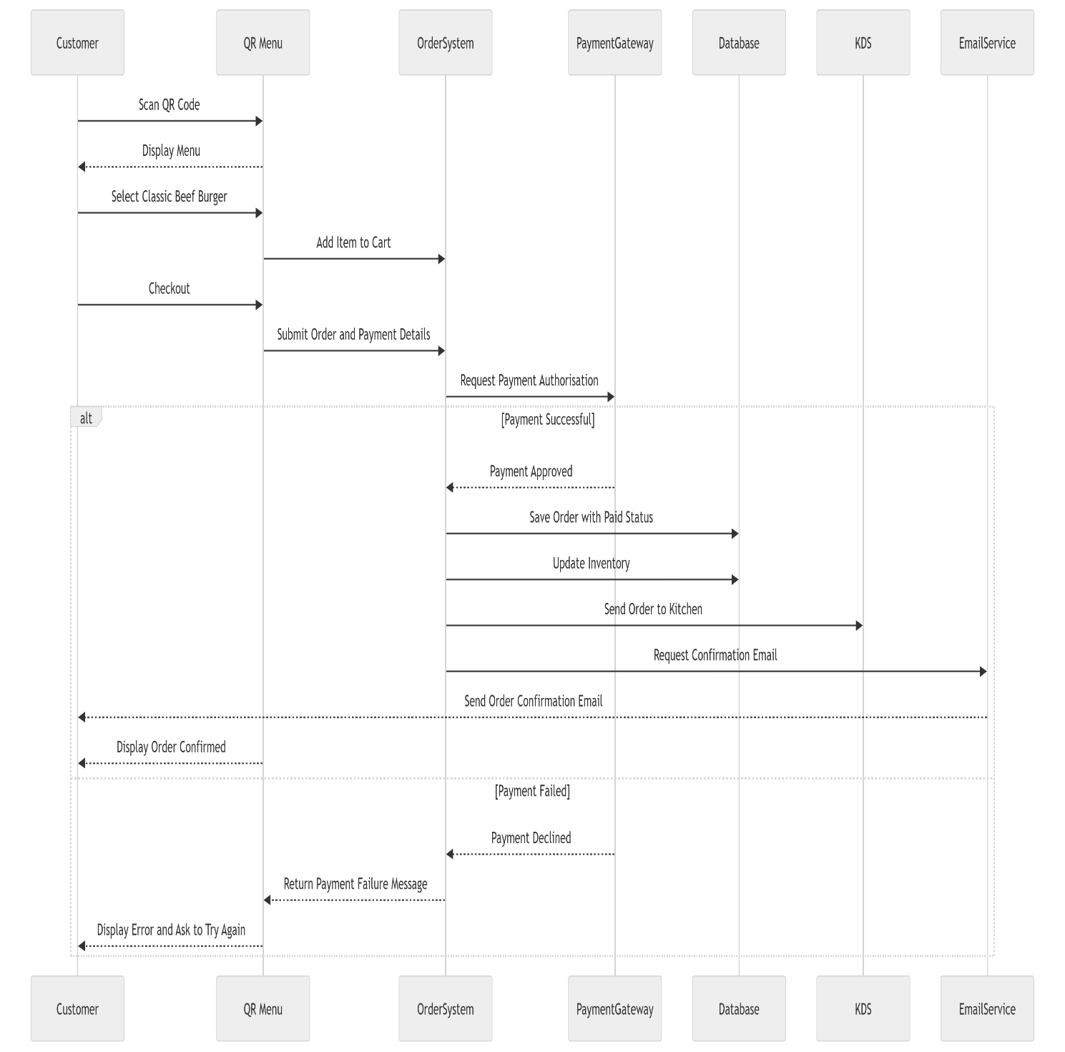
5.4 Component Design
The SmartBistro system is composed of several key components that work together to deliver core functionalities.
The Ordering System manages customer interactions from menu browsing to order submission. It communicates with the backend to process orders and store data.
The Payment Module handles transaction processing and communicates with external payment gateways to ensure secure payments.
The Inventory Management System tracks ingredient usage and updates stock levels in real time based on orders.
The Kitchen Display System (KDS) receives order information and displays it to kitchen staff, allowing them to manage preparation efficiently.
The Email Notification Service is responsible for sending order confirmations to customers after successful payment.
The Database (PostgreSQL) serves as the central data storage system, maintaining records of orders, payments, inventory, and customer information. It ensures data integrity and supports concurrent transactions.
These components interact through the application layer, ensuring smooth data flow and system coordination.

6. Tools and Technologies
To support the development and management of the SmartBistro system, several modern tools and technologies are selected to ensure efficiency, collaboration, and scalability.
Version Control – GitHub
GitHub is used for version control to manage the project source code and documentation. It allows team members to collaborate effectively, track changes, and maintain a clear development history through commits. This ensures accountability and supports collaborative development.
Project Management – Jira / Trello
A project management tool such as Jira or Trello is used to organise tasks, manage sprint backlogs, and track progress. It supports Agile Scrum practices by enabling task assignment, sprint planning, and visual tracking of development stages.
Backend Development – Django (Python)
Django is chosen as the backend framework due to its robustness, scalability, and built-in support for rapid development. It also provides strong support for database integration and security features, which are essential for handling transactions and user data.
Database – PostgreSQL
PostgreSQL is used as the relational database management system to ensure data integrity and support ACID transactions. This is particularly important for managing concurrent orders and maintaining accurate inventory levels.
Continuous Integration/Deployment – GitHub Actions (CI/CD)
GitHub Actions is used to automate testing and deployment processes. It helps ensure that updates are continuously integrated and reduces the risk of errors during development.
7. Project Management & Repository
GitHub was used as the main platform for version control and project management. The repository contains all project artifacts, including system diagrams, prototype designs, testing documentation, and development files. Commit history demonstrates the progress of the project and reflects the application of Agile development practices.
Click on link to access the Github process:
daidichcode/SmartBistro-SENG205

8. Testing and Quality Assurance
To ensure that the SmartBistro system performs reliably and meets user expectations, several testing approaches were applied throughout the development process. Each testing type focuses on a different aspect of the system, from individual features to overall user experience.
8.1 Functional Testing
Functional testing was carried out to verify that the main features of the system work as intended.
For example, customers should be able to scan a QR code and access the digital menu without issues. They should also be able to add items to the cart and complete the checkout process smoothly. In addition, the payment function must process transactions correctly and return a successful confirmation.
8.2 Integration Testing
Integration testing was used to ensure that different components of the system work together properly.
After a successful payment, the order should be correctly stored in the database. At the same time, the order must be sent to the Kitchen Display System so that the kitchen staff can begin preparation. The system should also automatically update inventory levels to reflect the items used in the order.
8.3 Database Testing
Database testing focused on maintaining data accuracy and consistency.
All order details, including items, prices, and table numbers, should be stored correctly in the database. The payment status must be updated to “Paid” once the transaction is completed. In addition, inventory data should be reduced appropriately based on the items sold.
8.4 User Acceptance Testing (UAT)
User Acceptance Testing was conducted to evaluate the system from the perspective of end users.
Customers should find it easy to navigate the menu and place orders without confusion. Staff members should be able to manage orders efficiently, while kitchen staff should clearly understand incoming requests. Overall, the system is expected to provide a smooth and user-friendly experience.
Test Case ID | Scenario | Steps | Expected Result | Status
TC01 | Customer views menu | Scan QR code | Digital menu is displayed | Pass
TC02 | Add burger to cart | Select Classic Beef Burger and click Add | Burger appears in cart | Pass
TC03 | Checkout order | Click Checkout | Order summary and total price are shown | Pass
TC04 | Successful payment | Click Pay Now with valid payment | Payment is approved | Pass
TC05 | Email confirmation | Payment completed | Confirmation email is sent to customer | Pass
TC06 | KDS receives order | Payment completed | Kitchen display shows new order | Pass
TC07 | Inventory update | Burger order confirmed | Burger ingredients are deducted | Pass
TC08 | Failed payment | Use invalid payment | Error message is displayed | Pass
TC09 | Low stock alert | Ingredient quantity below threshold | Low-stock warning appears | Pass
TC10 | Order status update | Chef marks order as Ready | Staff can see updated status | Pass
9. Timeline & Budget
10. Hi-Fidelity Prototype
The prototype is designed to simulate the user interface of the SmartBistro system, focusing on usability and clarity.
Simulating QR code:

- The menu interface allows customers to browse items and view prices.
The system allows customers to view detailed information about items, including descriptions, pricing, and customization options before adding them to the cart.
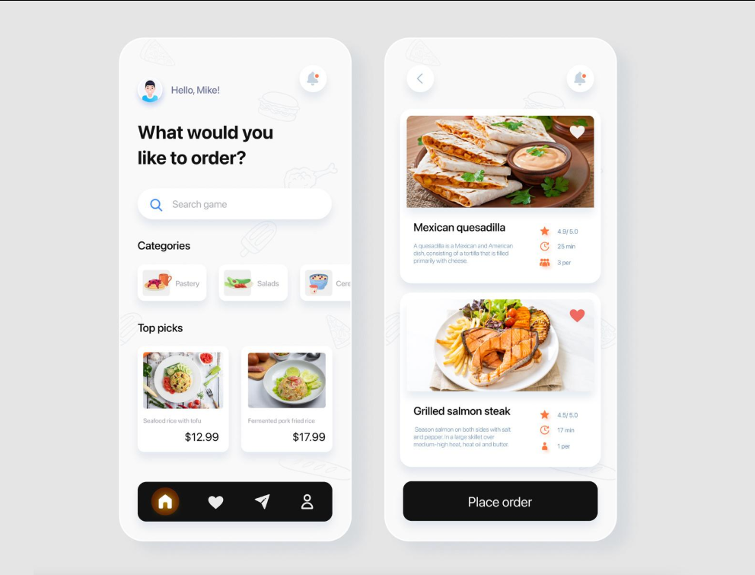
- The ordering interface enables users to select items and confirm purchases.
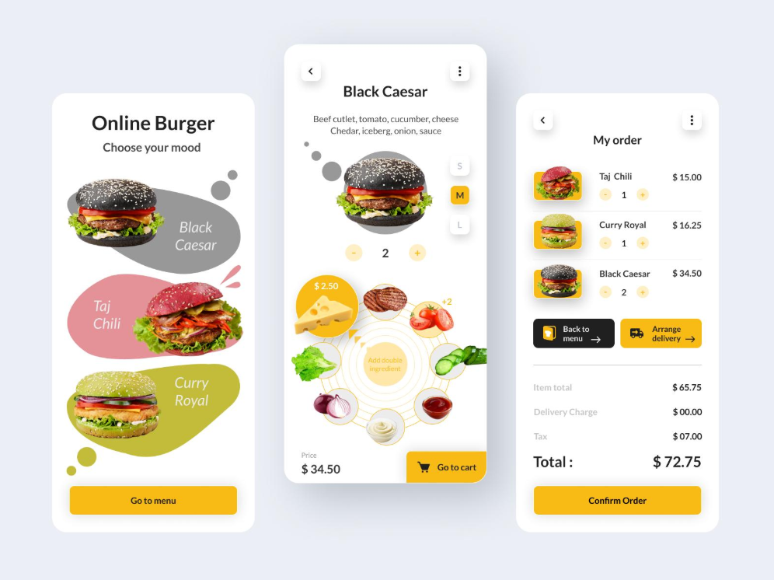
The system provides a checkout interface where customers can review their order and complete secure payment transactions.
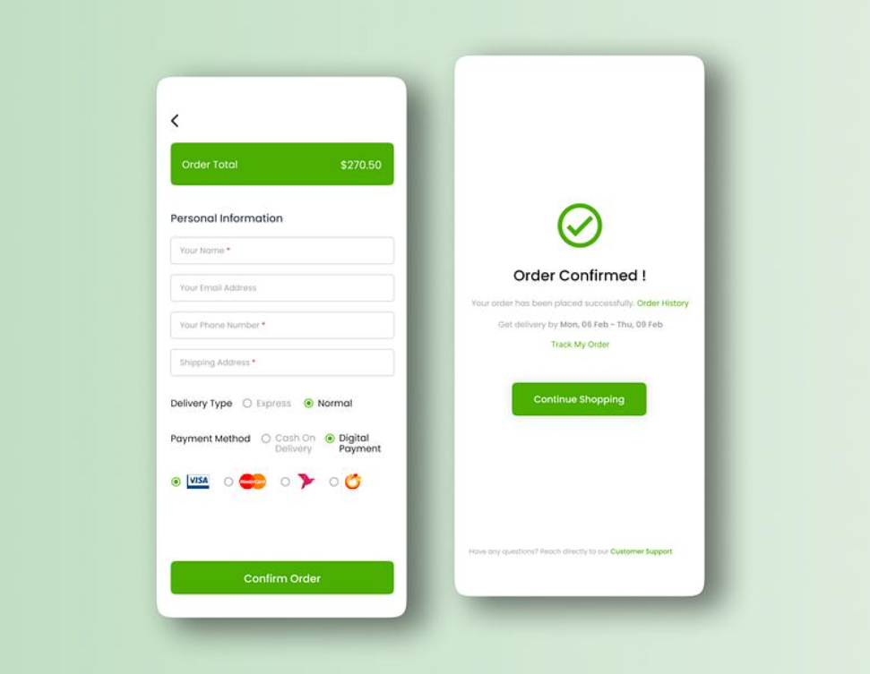After successful payment, the system generates an order confirmation and sends a notification email to the customer, ensuring transparency and order tracking.
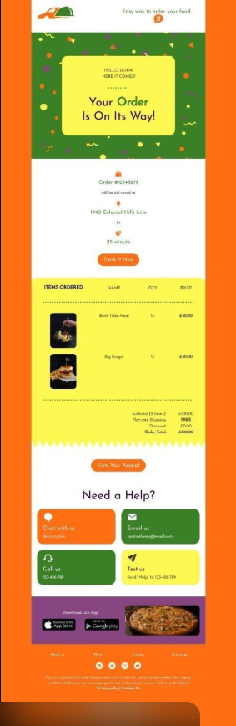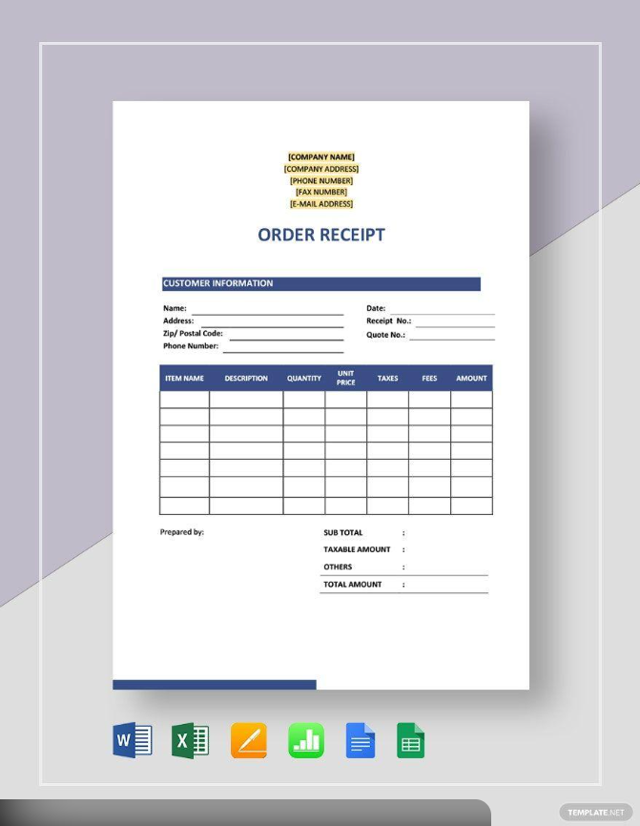
- The kitchen display screen provides real-time order updates for staff.
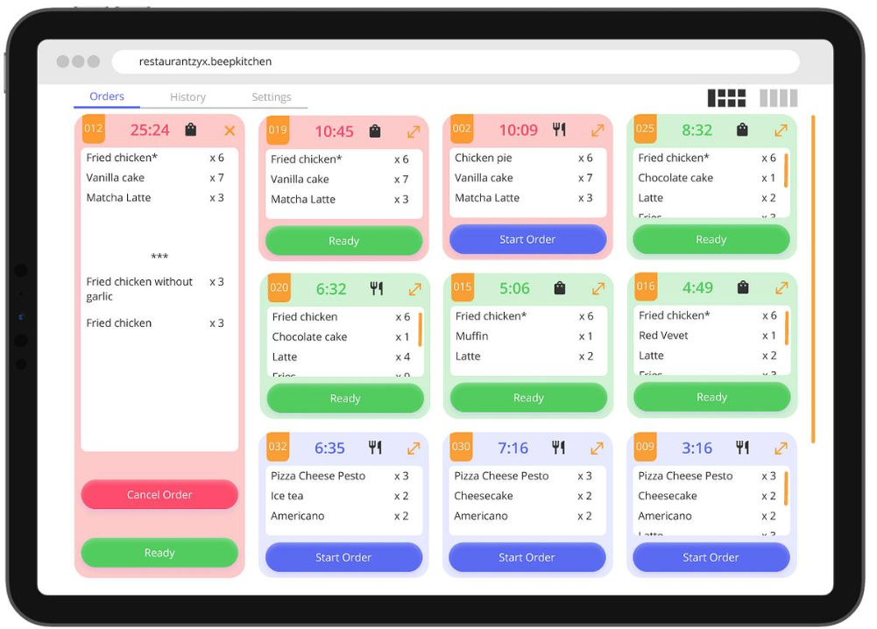
- The dashboard visualises key business metrics such as sales performance.

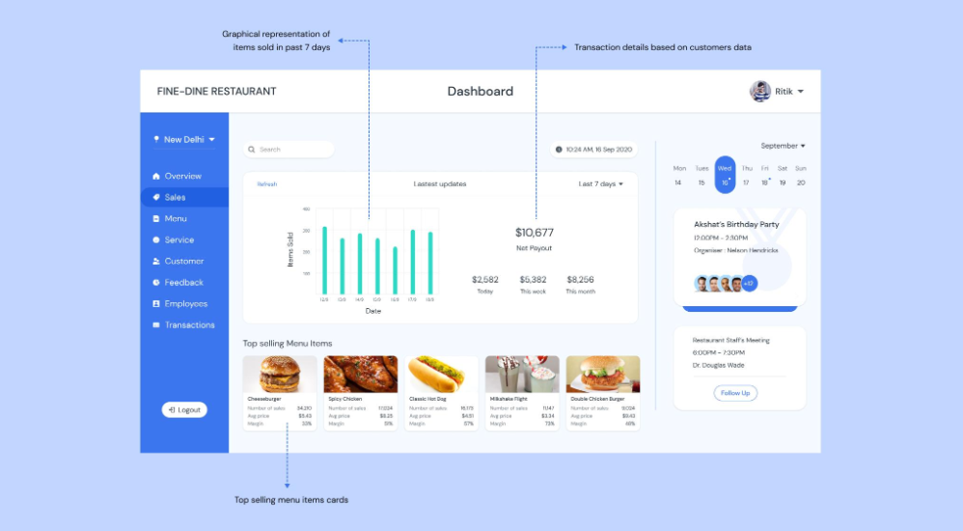
The prototype demonstrates the intended user experience and supports system design validation before implementation.
(All the pictures is for simulating display only – created by team members on Canvas)
11. Conclusion
In conclusion, the SmartBistro system is designed to address the operational challenges of modern high-volume restaurants by integrating ordering, kitchen management, inventory tracking, and analytics into a unified platform. The use of Agile Scrum methodology enables flexible development and continuous improvement throughout the project lifecycle. Additionally, the selection of modern tools and technologies supports efficient collaboration, system scalability, and data integrity. Overall, the proposed solution provides a practical and effective approach to improving both customer experience and restaurant operations.
12. References
1. Software Engineering
Sommerville, I. (2016) Software engineering. 10th edn. Harlow: Pearson.
https://www.pearson.com/en-gb/subject-catalog/p/software-engineering/P200000003480/
2. Agile / Scrum
Schwaber, K. and Sutherland, J. (2020) The Scrum Guide. Available at: https://scrumguides.org (Accessed: 30 April 2026).
3. Database
Elmasri, R. and Navathe, S. (2016) Fundamentals of database systems. 7th edn. Harlow: Pearson.
https://www.pearson.com/en-us/subject-catalog/p/fundamentals-of-database-systems/P200000003206/
4. System Architecture
Fowler, M. (2002) Patterns of enterprise application architecture. Boston: Addison-Wesley.
https://martinfowler.com/books/eaa.html
5. UX / Human Interaction
Norman, D. (2013) The design of everyday things. Revised and expanded edn. New York: Basic Books. https://www.nngroup.com/books/design-everyday-things-revised/

